# VII. INSTALLTION GUI AND USER MANUAL

## INSTALLTION GUI

### **English Version**

#### Prerequisites

This section contains the list of prerequisites that must be fulfilled before install.

* A smart phone running on Android ver 6.0 or higher. Or A smart phone running on IOS ver 8.3 or higher.
* 20MB free or higher

#### Installation procedures

* IOS: Copy ‘KarryWell.ipa’ file to the targeted device. Open and install
* Android:

1. Connect to internet
2. Tap on **Google play** icon on screen
3. Search Karry Well
4. Tap on **Install** button
5. Tap **Accept** button confirmation dialog

#### Uninstall procedures

1. Tap **Apps** in the upper right hand corner

1. Tap on **Setting**
2. Tap **Applications** to the left of the screen.
3. Tap **Manage applications** on the right side of the screen.
4. Tap on **Karry Well**
5. Tap the **Uninstall** button.
6. To confirm you want to uninstall this app tap **OK**.
7. Click **OK** once finished.

### **1.2. Japanese Version**

#### 1.2.1. 前提条件

このセクションにはアプリをインストールするための前提条件を表します。

* Android バージョン4.4.2以上, IOS バージョン8.3以上 で動くスマートフォン
* 20MB以上のフリー の容量

#### 1.2.2. インストール手順

* IOS: IOS 端末に‘KarryWell.ipa’ファイル をファクスす
* Android:
  + 1. インターネットに接続する
    2. 画面に現れるグーグルプレアイコンに押す
    3. Karry Well を検索する
    4. インストールボタンに押す
    5. 確認ダイアログのはいボタンに押す

#### 1.2.3. アンインストール手順

1. 右上コーナーにアプリを押す
2. 設定に押sす
3. 画面の左に現れるアプリケーションに押す
4. 画面の右側にあるアプリ管理に押す
5. Karry Well に押す
6. アンインストールボタンに押す
7. このアプリのアンインストールを確認するためOKに押す
8. アンインストールが終わったらOKに押す

## 2. USER MANUAL

### **2.1. Web Application**

#### 2.1.1. Admin View

This document guides you how to use KarryWell client-web application for admin. You will need only 10 minutes to learn.

##### 2.1.1.1. Login to system

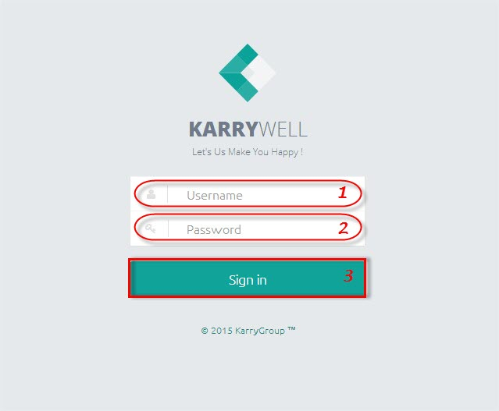

**To login to KarryWell system:**

**Step 1**. Type your “Username” on username text box (“1”)

**Step 2**. Type your “Password” on password text box (“2”)

**Step 3**. Click on “Sign in” button (“3”)

##### 2.1.1.2. Select a screen

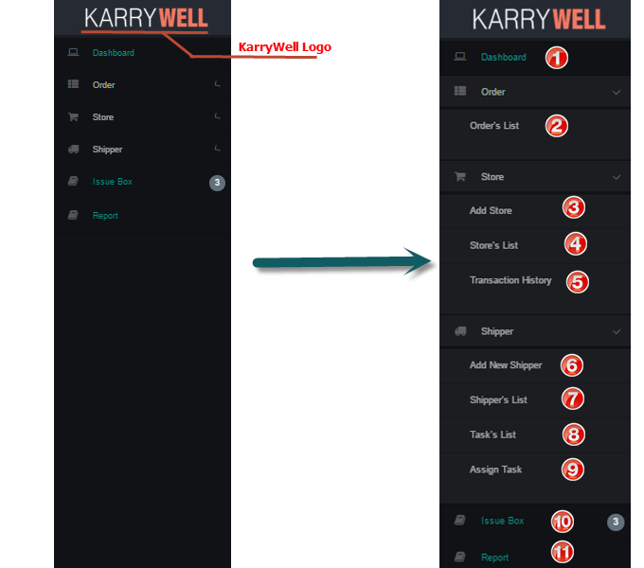

**To select a screen**

1. Click on screen that you want to go on left navigate bar

* ➊Dashboard: used to view statistics and overview of system
* ➋Order’s List: used to view all orders and related information
* ➌ Add Store: used to add new Store to system
* ➍Store’s List : used to view all Store, block store and confirm payment
* ➎Transaction History: used to view all transactions
* ➏Add Shipper: used to add new Shipper to system
* ➐Shipper’s List: used to view all Shipper and related information
* ➑Task’s List: used to view all Tasks and related information
* ➒Assign Task: used to assign order to shipper
* ➓IssueBox: used to view and resolve issue
* ⓫Report: used to view statistics about system by month, year

##### 2.1.1.3. Add new Store

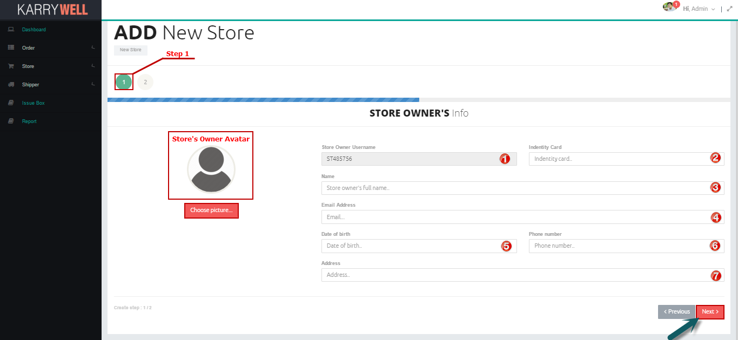

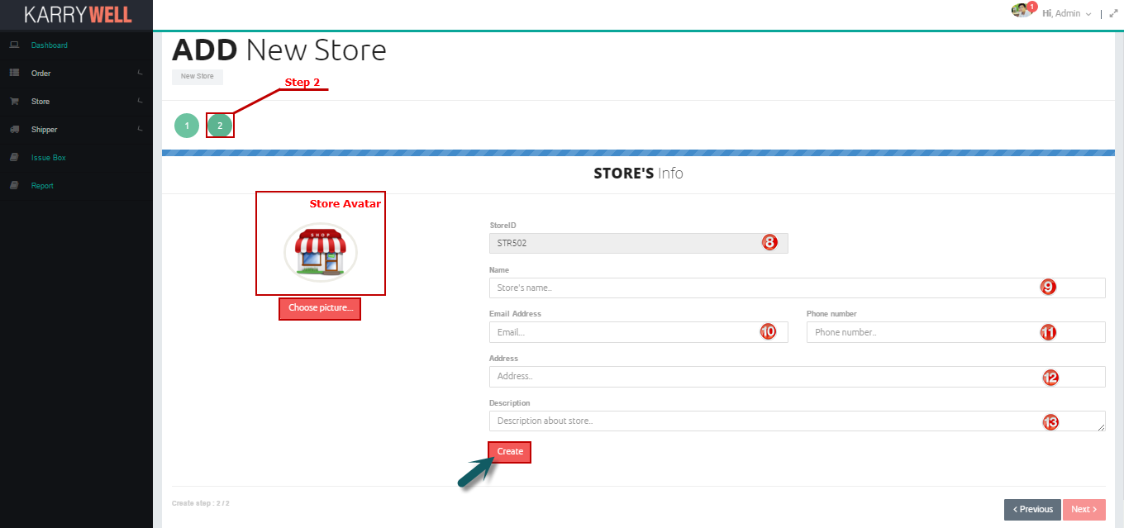

**To add new Store**

1. Open “Add Store” Screen
2. Enter valid store owner information into textbox, choose avatar if it is necessary:

* Identity card➋: identity card of store’s owner, user have to enter a string of digits from 9 to 12 characters
* Name➌: Full name of store’s owner
* Email➍: Email of store’s owner, must follow email format
* Date of Birth➎: date of birth of store’s owner, click into textbox, a calendar will be showed, user click into day in calendar to pick.
* Phone Number➏: phone number of store’s owner, user have to enter a string of digits from 11 to 12 characters
* Address➐: detail address of store’s owner

1. Click Next button
2. Enter valid store information into textbox, choose avatar if it is necessary

* Name➒: Full name of store
* Email➓: Email of store, must follow email format
* Phone Number⓫: phone number of store, user have to enter a string of digits from 11 to 12 characters
* Address⓬: detail address of store
* Description⓭: description about store

1. Click Create button

##### 2.1.1.4. Add new Shipper

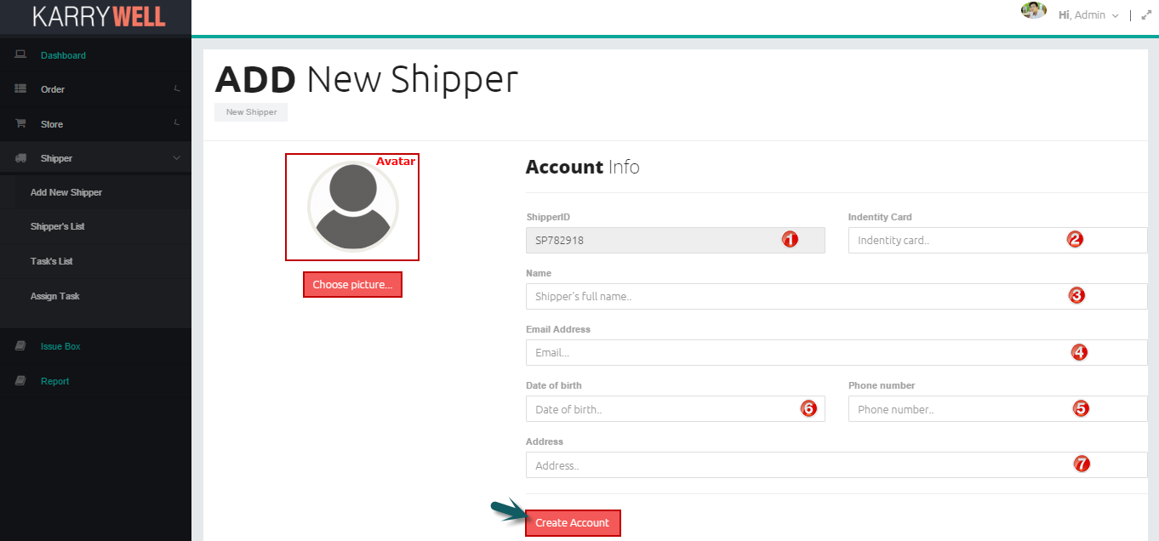

**To add new Shipper**

1. Open “Add Shipper” Screen
2. Enter valid shipper information into textbox, choose avatar if it is necessary

* Identity card ➋: identity card of shipper, user have to enter a string of digits from 9 to 12 characters
* Name ➌: Full name of shipper
* Email➍: Email of shipper, must follow email format
* Date of Birth➏: date of birth of shipper, click into textbox, a calendar will be showed, user click into day in calendar to pick.
* Phone Number➎: phone number of shipper, user have to enter a string of digits from 11 to 12 characters
* Address➐: detail address of shipper

1. Click Create button

##### 2.1.1.5. Confirm Payment

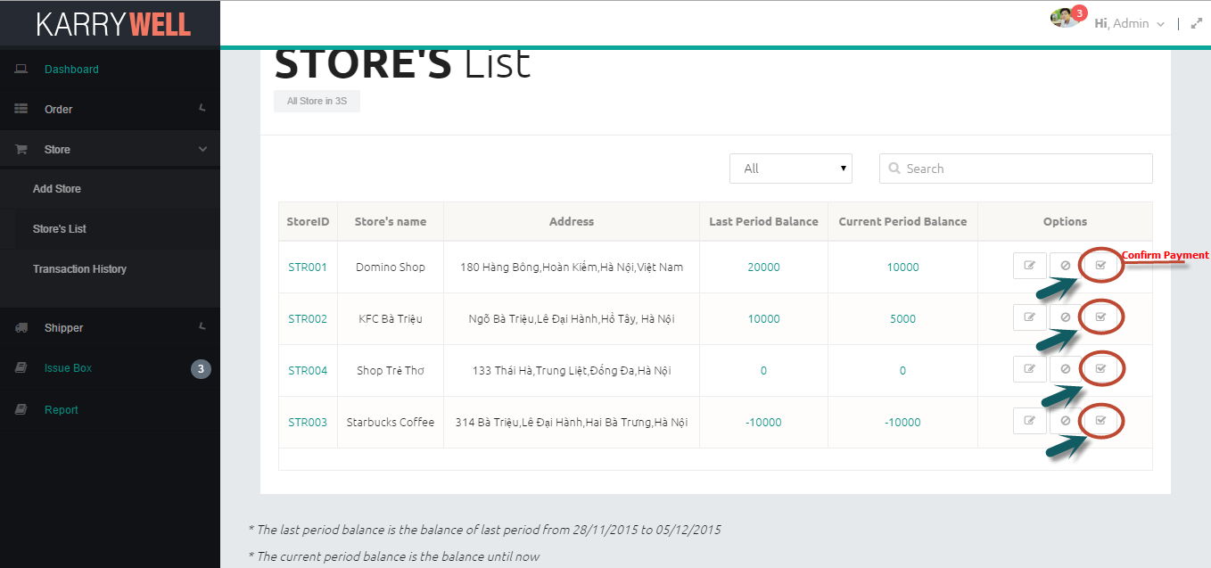

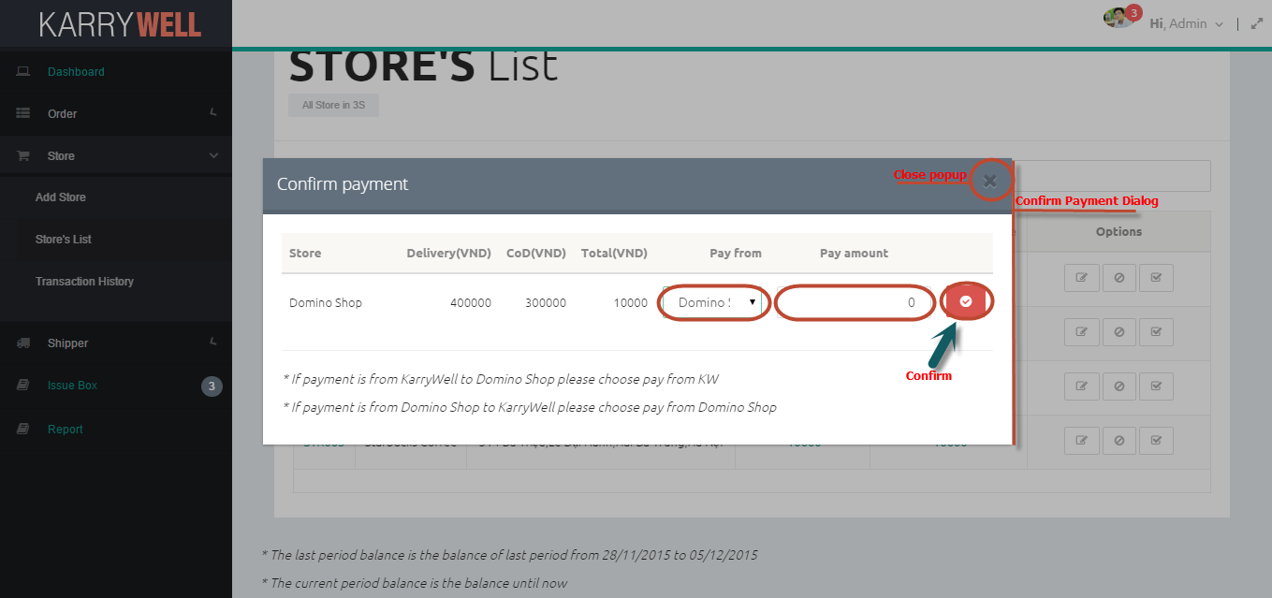

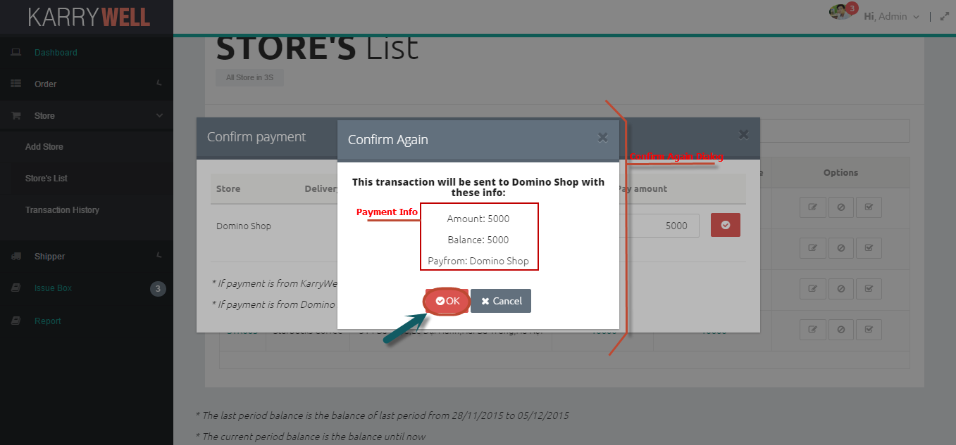

**To confirm payment**

1. Open “Store’s List” Screen
2. Click on Confirm Payment icon button
3. After confirm payment popup is showed:

* Pick payfrom drop-down list ➊:

+ If pick KarryWell, this payment is from system to store

+ If pick store’s name, this payment if from store to system

* Enter amount ➋ of payment, amount must be digits and not equal 0

1. Click on button Confirm
2. After Confirm Again popup is showed, user read payment information carefully then click “OK” button to add this transaction or cancel to close this popup

##### 2.1.1.6. Block/Unblock Store

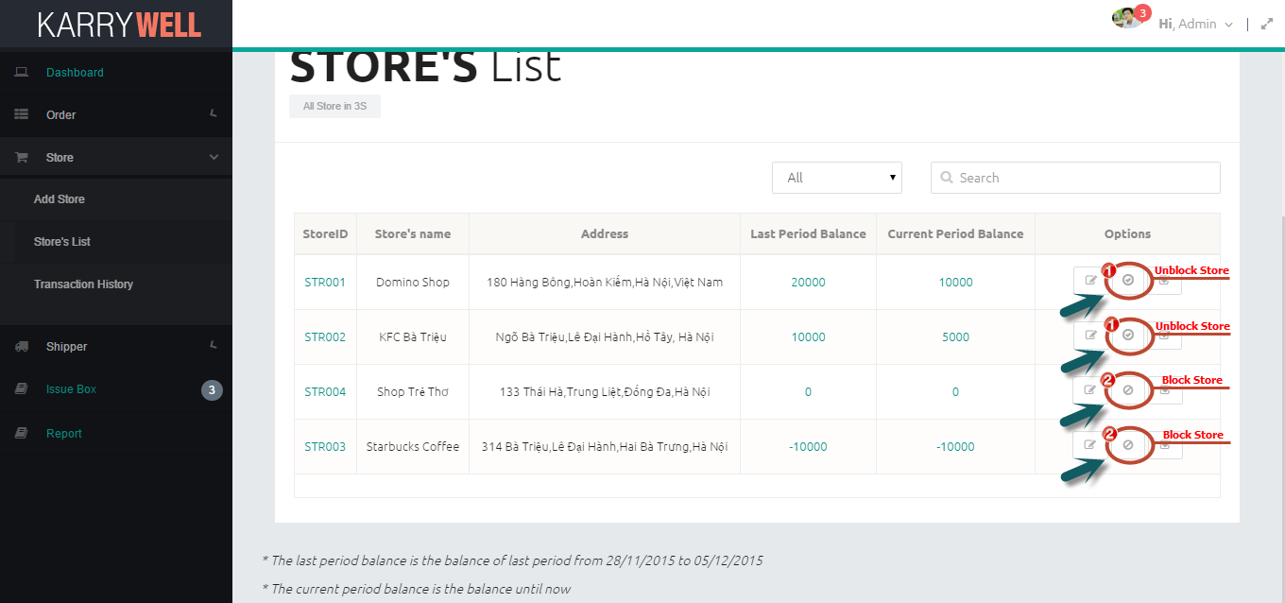

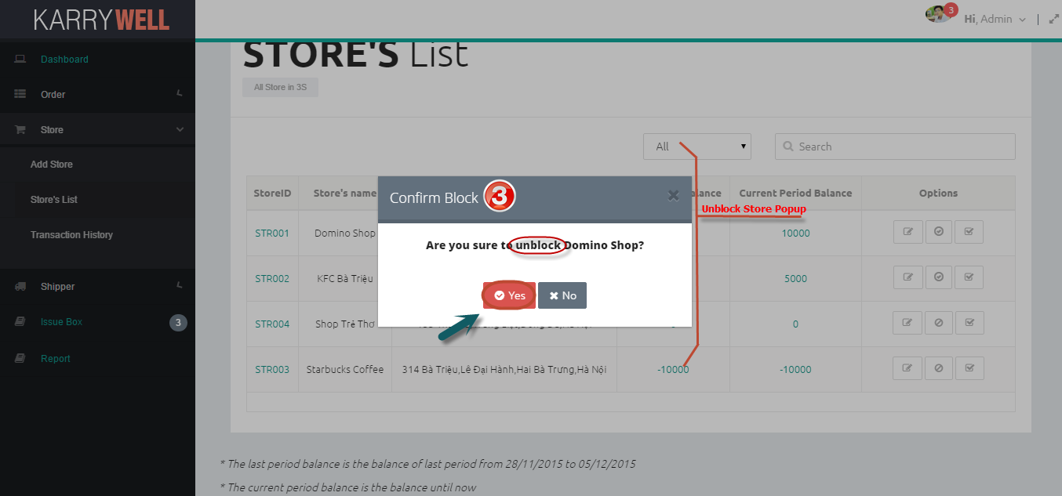

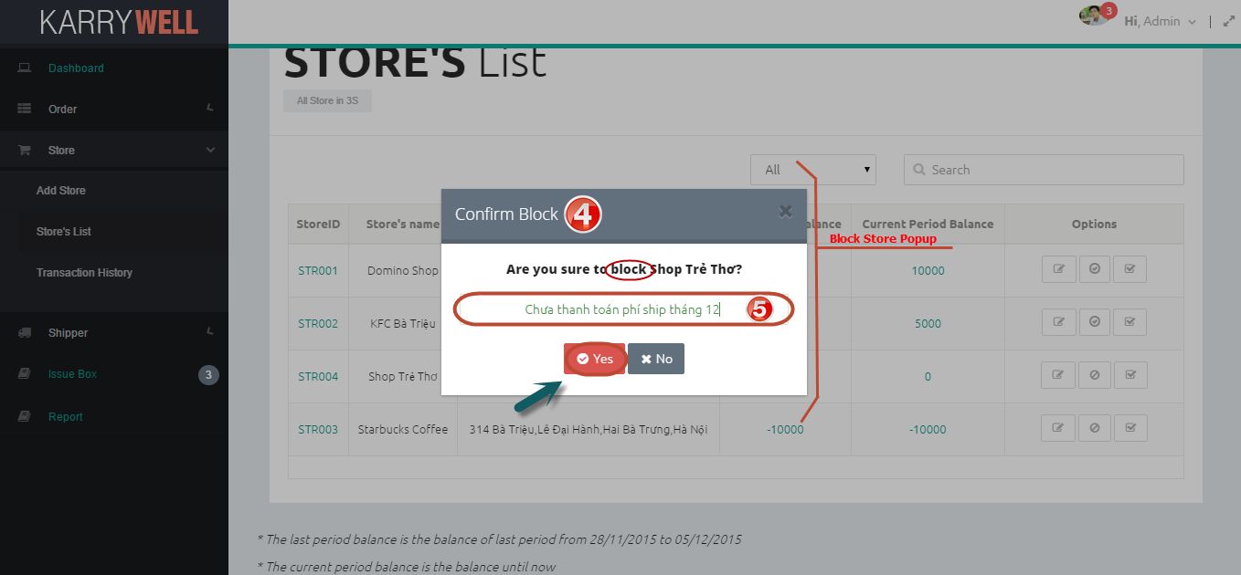

**To block/unblock store**

1. Open “Store’s List” Screen
2. Click on Block ➊ or Unblock ➋ store icon button
3. A popup will be showed:

* If Unblock Popup ➌ is showed, user click button “Yes” to unblock this store or “No” to close popup
* If Block Popup ➍ is showed, user enter reason in reason textbox ➎ (not blank) then click button “Yes” to block this store or “No” to close popup.

##### 2.1.1.7. Assign Task

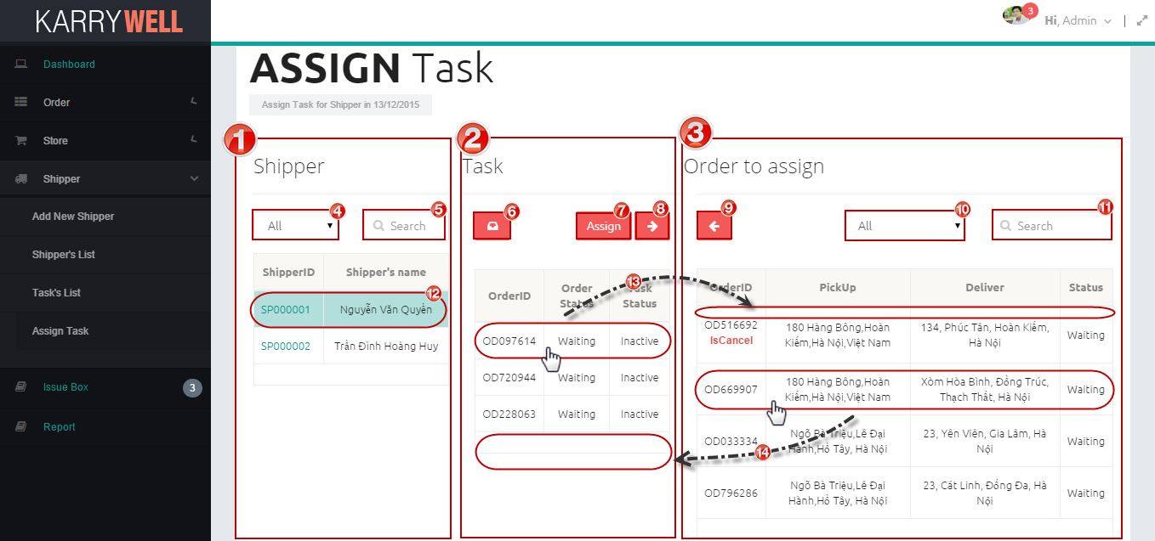

**Screen Description:**

1. Shipper area ➊: includes all shippers, textbox and filter for search shipper

* Filter ➍: user can pick type to search shippers by name, id or both
* Search ➎: user type search key to search shipper
* ⓬ When user select a row of shipper, all tasks of this shipper that can be assigned for other shipper will be listed in task table

1. Task area ➋: includes all tasks that can be assigned for other shipper and function buttons:

* IssueBox ➏: click to go to IssueBox page
* Assign➐: Click to assign task
* Move all to left➑: Move all order of picked shipper to Order table
* ⓭ When user pick task in a row of task table, order of this row will be moved from task table to order table

1. Order Area ➌: includes all orders can be assigned for shipper in order table, textbox and filter for search order:

* Filter ➓: user can pick type to search orders by id, address, status or all
* Search⓫ : user type search key to search order
* Move all to right➒: Move all order in Order table to task table
* ⓮ When user pick order in a row of order table, order of this row will be moved from order table to task table

**To assign task for Shipper**

1. Open “Assign Task” Screen
2. Select Shipper to assign by select row of shipper table ⓬
3. Pick order for shipper by select order on order table ⓮. User also can cancel task by select row of task in task table ⓭, but task is cancelled must be assigned for other shipper.

User can user button move all ➑➒ to pick order and task faster.

1. Click Assign button to assign tasks for shippers

##### 2.1.1.8. Resolve Issue

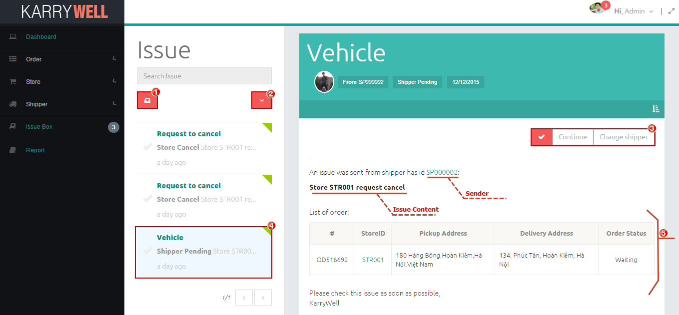

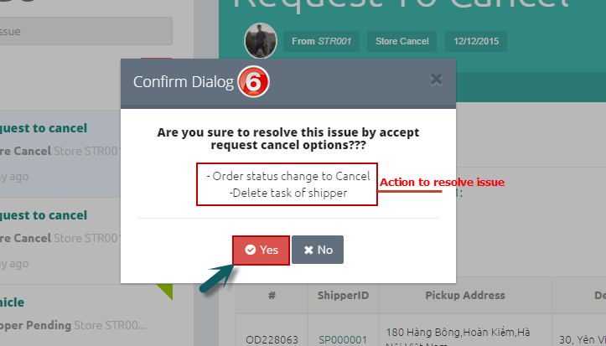 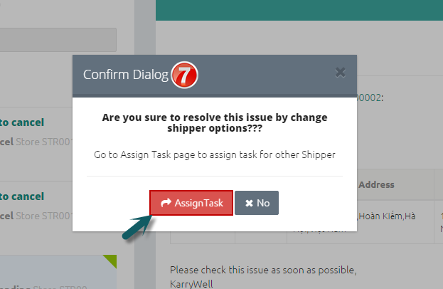

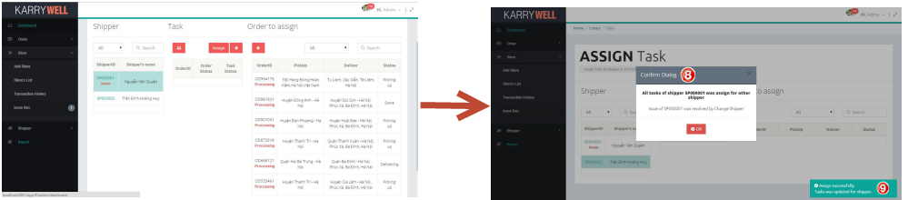

**Screen Description:**

1. Click ➊ to list all issues
2. Filter ➋: Click to view only selected type of issue, includes: Resolved, Unresolved, Shipper Pending, Shipper Cancel, Store Cancel
3. Click on button of resolve type ➌ to resolve issue, there are 3 types:

* Continue: for Shipper Pending issue, allow shipper continue orders which get issue
* Change Shipper: for Shipper Pending issue, change orders to other shipper
* Accept Request: for Shipper Cancel and Store Cancel, accept cancel request

1. Issue ➍: include type (hyperlink), category, content and resolve icon (✓) (is yellow if issue was resolved). User can click on type to view issue detail
2. ➎ List of orders that get issue

**To resolve issue**

1. Open “IssueBox” Screen
2. Pick issue on issue list to resolve
3. After reading content of issue carefully, user choose type of resolve: Continue, Change Shipper or Accept Request
4. A popup will be showed:

* If resolve type is Continue and Accept Request, a popup ➏ shows what system do to resolve issue, then user click “Yes” button to resolve issue or click “No” button to close popup
* If resolve type is Change Shipper:

+ Click “Assign Task” button on popup ➐ to go to Assign page

+ Assign Task for other Shipper (read user manual 2.5 for more detail)

+ After assign, if all issue orders of shipper is assigned for other shipper, a notify popup ➑ and notify message ➒ will be showed. User click “OK” button to back to IssueBox Screen

##### 2.1.1.9. Search

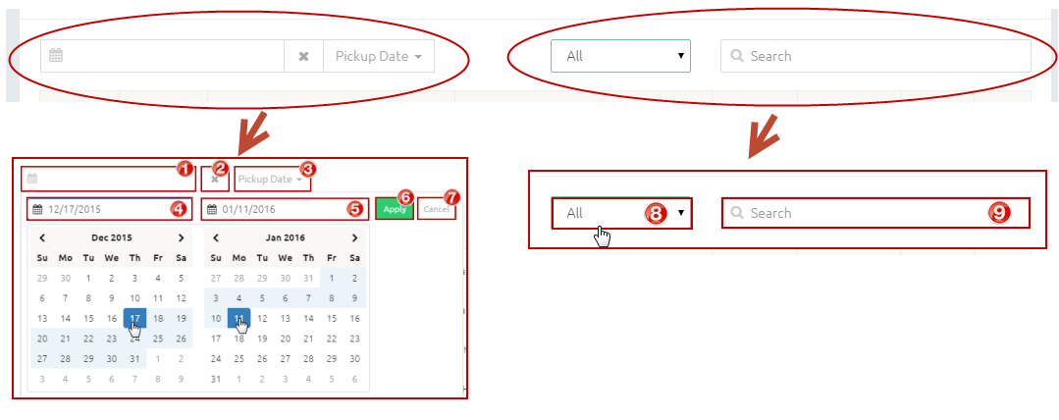

In each view list screen, there is a search tool to help user to search faster

**Screen Description:**

1. Click ➊ to show calendar to pick date
2. Click ➋ to clear date in textbox ➊
3. Click ➌ to choose which type of date will be searched, and some screens don’t have this
4. ➍ Start Date of date range
5. ➎End Date of date range
6. Click ➏ to apply date range after choose start date and end date
7. Click ➐ to Cancel
8. Click ➑ to show filter for search
9. Enter search key into textbox ➒ to search

**To search by date range**

1. Choose date type ➋. If screen doesn’t have drop down list ➋, default type of search date is which type of date in table below
2. Click date range textbox ➊ to pick date
3. Click start date and end date
4. Click “Apply” button ➏, then result will be displayed

**To search by word**

1. Choose type to filter ➑. “All” is search by all information in table below
2. Enter search key into textbox ➒. Whenever type any key in search textbox, result will be displayed immediately

##### 2.1.1.10. View Detail

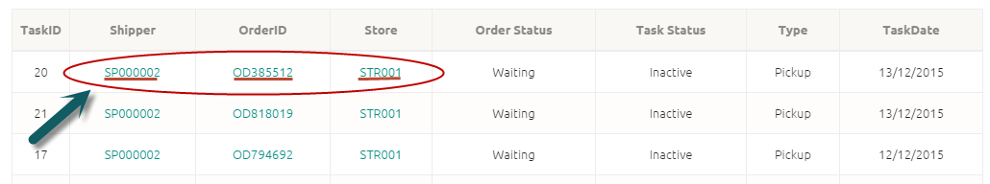

In each view list screen, there are hyperlink to store detail, order detail, shipper’s profile. User just click to this hyperlink to view detail

#### 2.1.2. Store View

##### 2.1.2.1. Login to system



**To login to KarryWell system:**

**Step 1**. Type your “Username” on username text box (“1”)

**Step 2**. Type your “Password” on password text box (“2”)

**Step 3**. Click on “Sign in” button (“3”)

##### 2.1.2.2. Open a screen

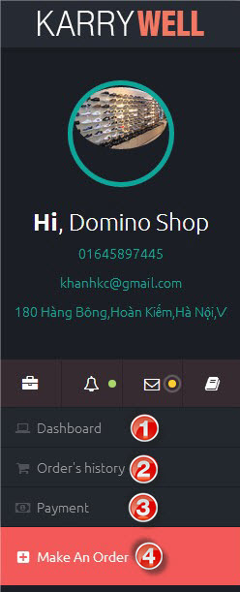**To open a page:**

On right menu, have a list names of screen. You can click on those name to open a screen.

- ➊ : Open Dashboard screen.

- ➋ : Open Order’s history screen.

- ➌ : Open Transaction history screen.

- ➍ : Open Create order screen.

##### 2.1.2.3. View Profile

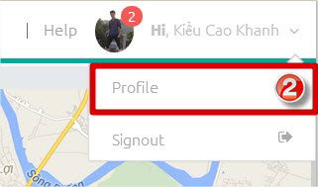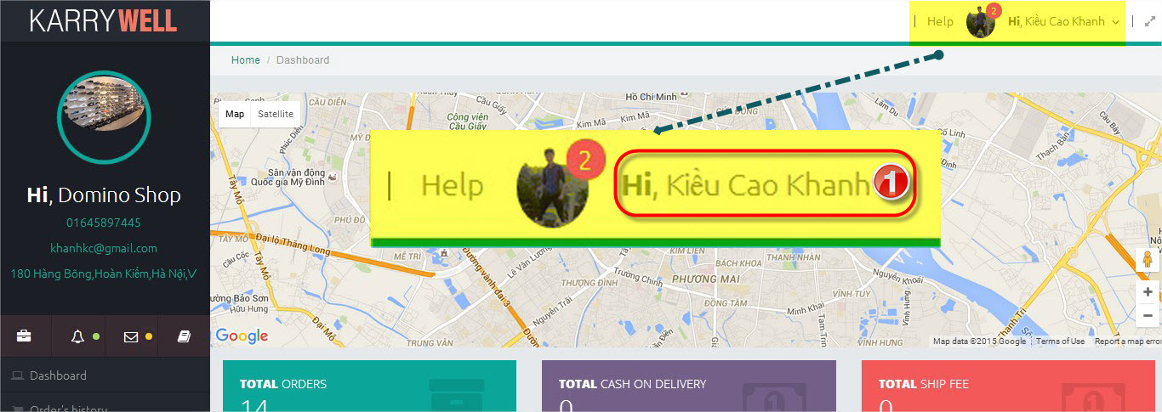

You can access to profile screen from any screen.

**To view profile screen:**

**Step 1**. Click on your name on header (➊). A menu will appear.

**Step 2**. Click on “Profile” item on menu (➋).

##### 2.1.2.4. Create an order

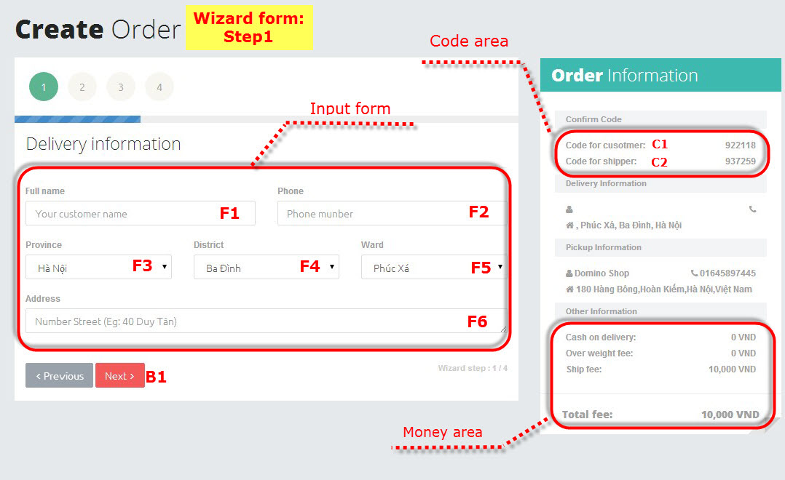

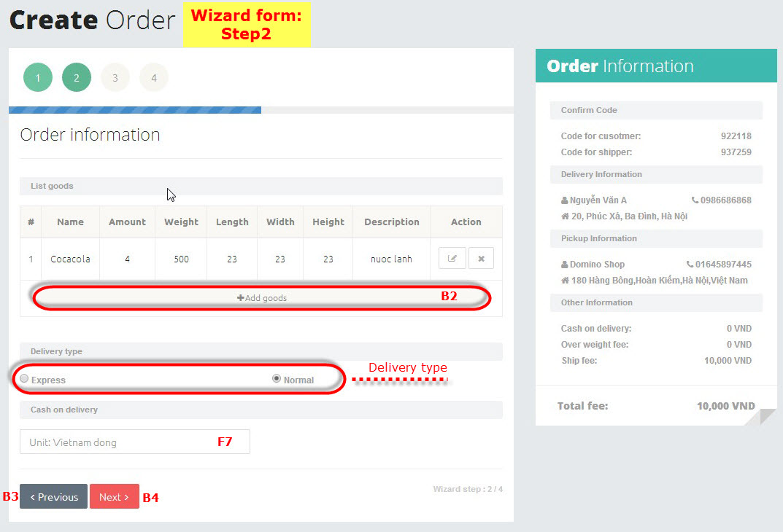

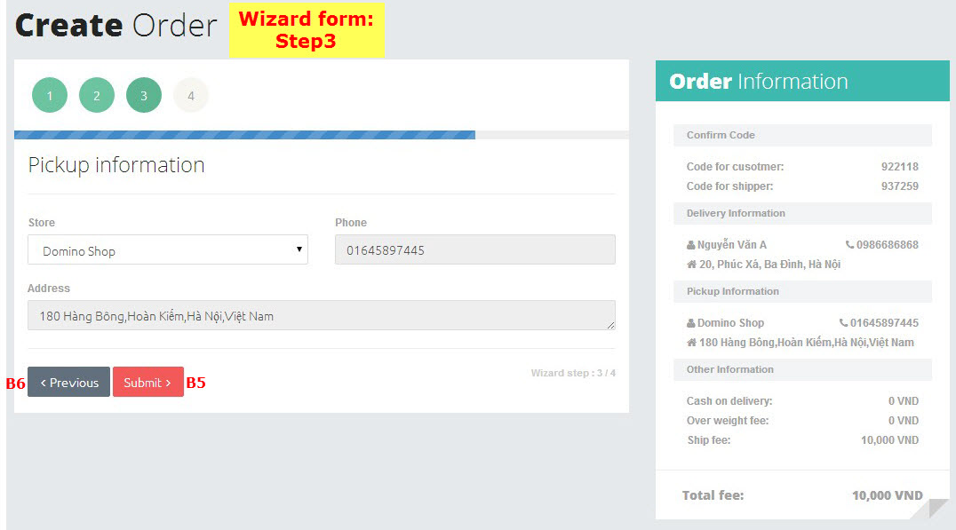

- There is one wizard form on “Create order” screen. You just need to follow on below steps to create an order.

**To create an order:**

**At “Wizard form: Step1”**

**Step 1**. Open “Create order” screen (see 3.2.2: Open a screen).

**Step 2**. Input data on “Input form”

- 1. Type the full name of your customer on (F1).

- 2. Type the phone number of your customer on (F2).

- 3. Click on (F3) to select province of your customer.

- 3. Click on (F4) to select district of your customer.

- 4. Click on (F5) to select ward of your customer.

- 5. Type the address of your customer on (F6).

**Step 3**. Click on “Next” button (B1) to go to “**Wizard form: Step 2**”.

**At “Wizard form: Step2”**

**Step 4**. Click button “Add goods” (B2) to add a goods to order (see 3.2.5: Add a goods).

You can edit and delete goods on table of goods (see 3.2.6: Edit a goods and 3.2.7: Delete a goods)

**Step 5**. Select delivery type on “Delivery type” area.

- Express: System will find a shipper for you and that shipper will come to pick up your goods immediately.

- Normal: Shipper will come to pick up your goods in tomorrow.

**Step 6**. Type amount of cash on delivery on “Cash on delivery” text box (F7)

**Step 7.** Click “Next” button (B4) to go to “Wizard form: Step 3”. If you want to go to “Wizard form: step 1” click on “Precious” button (B3).

**At “Wizard form: Step 3”** (This screen display information of your store)

**Step 8:** Click on “Submit” button (B5) to submit your order.

- If at “**Step 5**” you chose “Normal”, you are create an order successfully, go to “Dashboard” screen to view you order.

- If at “**Step 5**” you chose “Express” system will find a shipper for you. (see 3.2.13.Find a shipper

##### 2.1.2.5. Add a goods

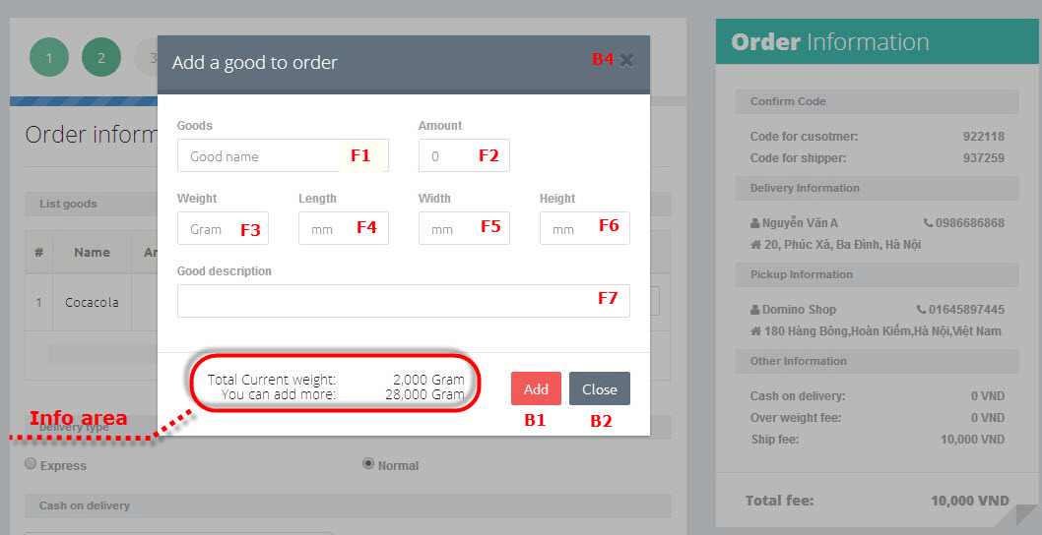

You can add a goods to order form “Create an order” screen (see 3.2.4. Create an order) and “Edit an order” screen (see 3.2.11. Edit an order)

**To add a goods to order**

**Step 1. Type information of goods**

- 1. Type name of goods on “Goods name” text box (F1).

- 2. Type amount of goods on “Amount” text box (F2).

- 3. Type weight of goods on “Weight” text box (F3).

- 4. Type length size of goods on “Length” text box (F4).

- 5. Type width size of goods on “Width” text box (F5).

- 6. Type height size of goods on “Height” text box (F6).

- 7. Type description of goods on “Description” text box (F7)

**Step 2.** Clicks on “Add” button (B1) to add goods to order. If you don’t want to add goods click on “Close” button (B2) or “X” button (B4)

**\* Note**: On Info area there are 2 line

- Total current weight: total weight of all goods in order.

- You can add more: total weigh you can add to order.

##### 2.1.2.6. Edit a goods

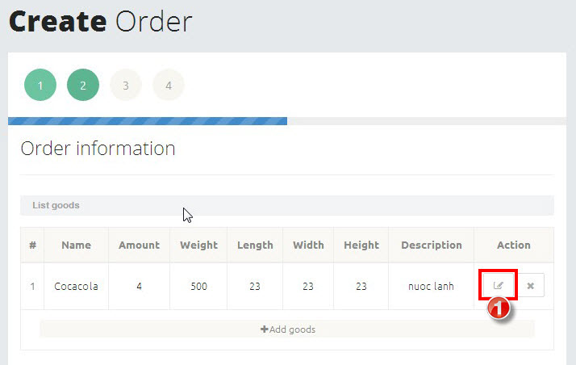

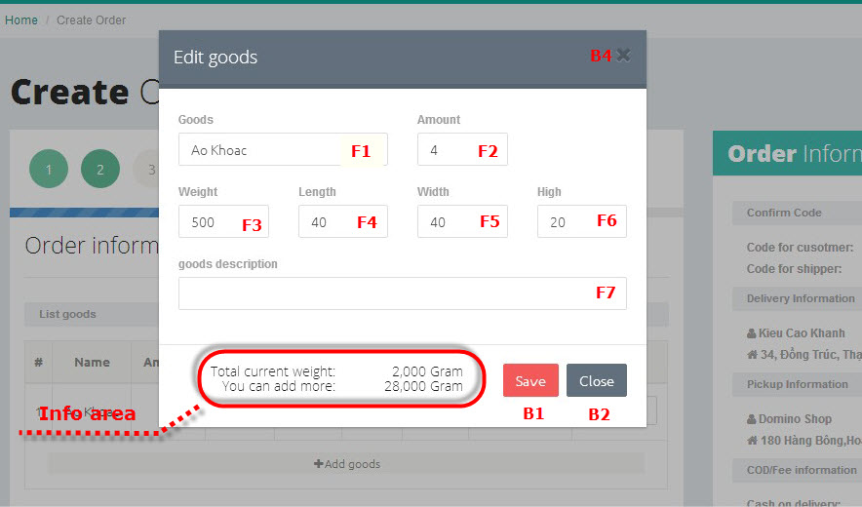

You can edit a goods on “Create an order” screen (see 3.2.4. Create an order) and “Edit an order” screen (see 3.2.11. Edit an order)

**To edit a goods**

**Step 1.** Click on pen icon (➊).

**Step 2.** Editinformation of goods.

- 1. Edit name of goods on “Goods name” text box (F1).

- 2. Edit amount of goods on “Amount” text box (F2).

- 3. Edit weight of goods on “Weight” text box (F3).

- 4. Edit length size of goods on “Length” text box (F4).

- 5. Edit width size of goods on “Width” text box (F5).

- 6. Edit height size of goods on “Height” text box (F6).

- 7. Edit description of goods on “Description” text box (F7)

**Step 3.** Clicks on “Save” button (B1) to save information of goods. If you don’t want to save the change click on “Close” button (B2) or “X” button (B4)

**\* Note:** On Info area there are 2 line

- Total current weight: total weight of all goods in order.

- You can add more: total weigh you can add to order.

##### 2.1.2.7. Delete a goods

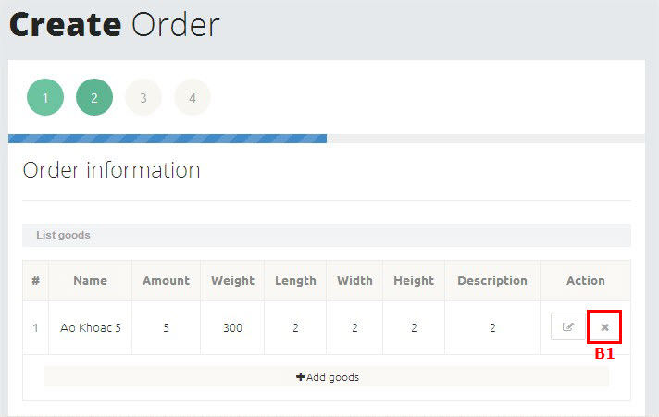

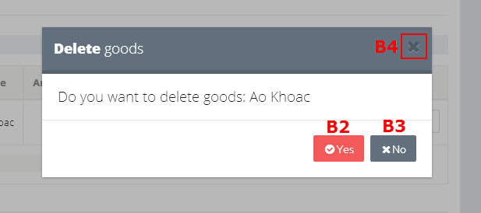

You can delete a goods from “Create an order” screen (see 3.2.4. Create an order) and “Edit an order” screen (see 3.2.11. Edit an order)

**To delete a goods**

**Step 1.** Click on “X” button (B1). A confirm popup will appear.

**Step 2.** Click on “Yes” button to delete goods. If you don’t want to delete that goods any more click on “No” button (B3) or “X” button (B4) to close confirm popup.

##### 2.1.2.8. Delete an order

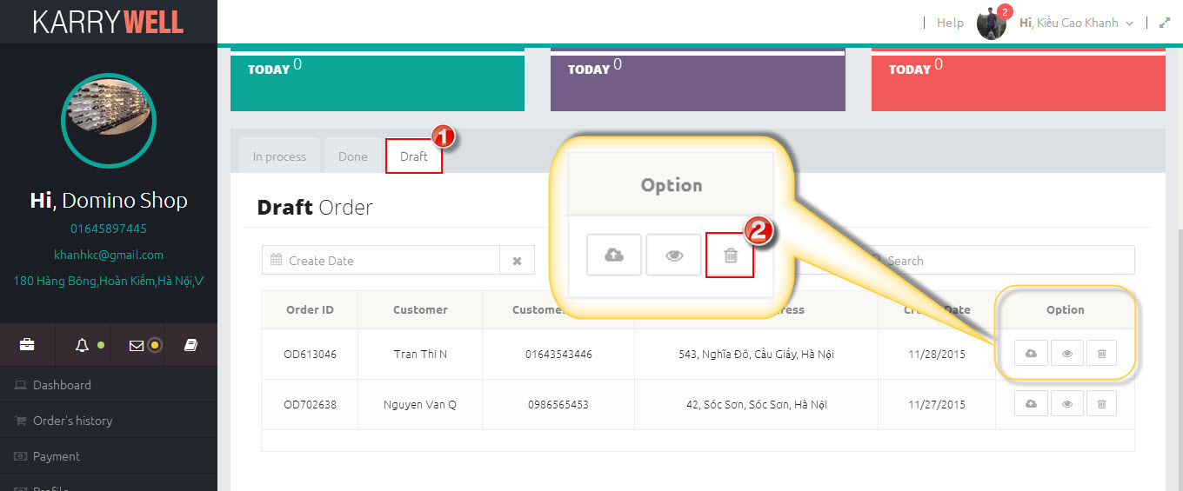

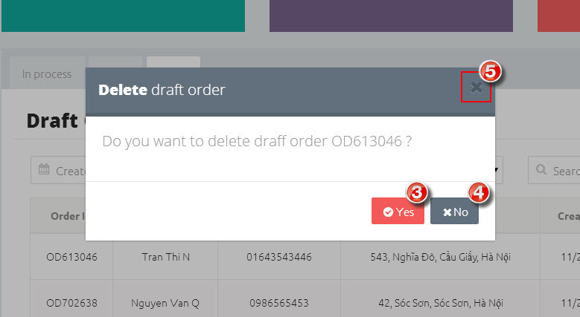

**\* Note:** You can only delete orders that have not been grabbed yet by any shipper (Draft order)

**To delete an order**

**Step 1.** Click on “Draft” tab (➊) on “Dashboard” screen to open table of draft orders.

**Step 2.** Click on trash icon (➋). A popup will appear.

**Step 3.** Click on “Yes” button (➌) to confirm delete order. If you don’t want to delete that order any more, click on “No” button (➍) or “X” button (➎) to close popup.

##### 2.1.2.9. Cancel an order

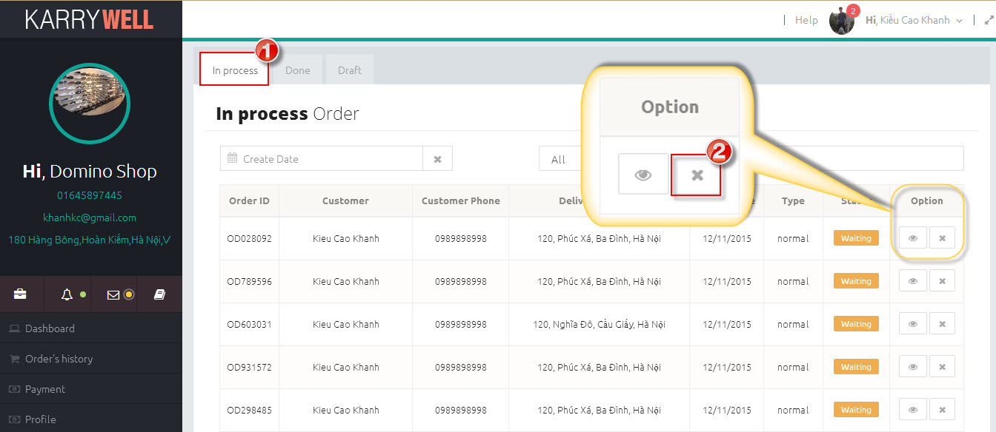

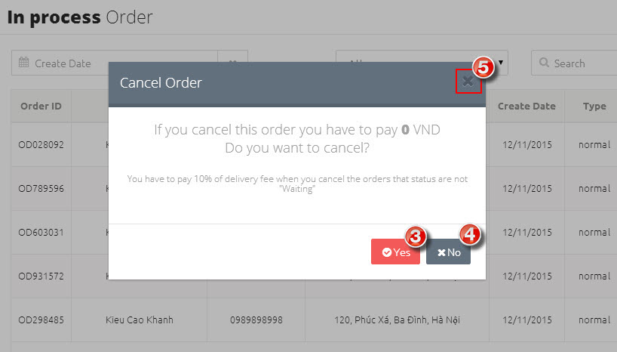

**\* Note:** You can only cancel an orders that have not been completed.

**To cancel an order**

**Step 1.** Click on “In process” tab (➊) on “Dashboard” screen to open table of draft orders.

**Step 2.** Click on “X” button (➋). A popup will appear.

**Step 3.** Click on “Yes” button (➌) to confirm cancel order. If you don’t want to cancel that order any more, click on “No” button (➍) or “X” button (➎) to close popup.

##### 2.1.2.10. View detail of an order

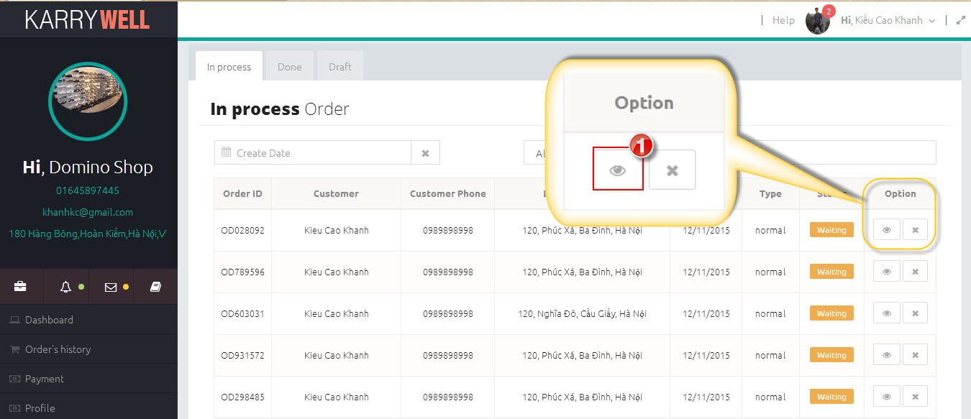

**To view detail of an order:**

You can view detail of an order by click on button that has an eye icon inside.

##### 2.1.2.11. Edit an order

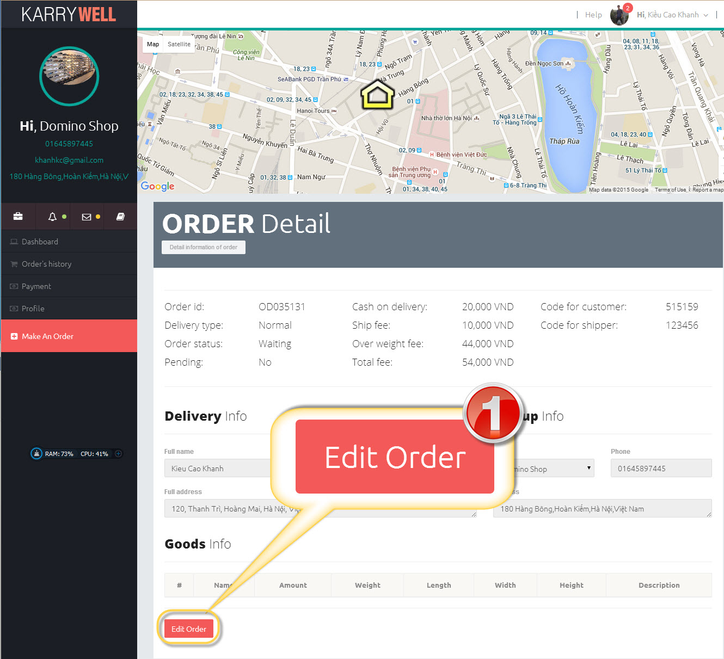

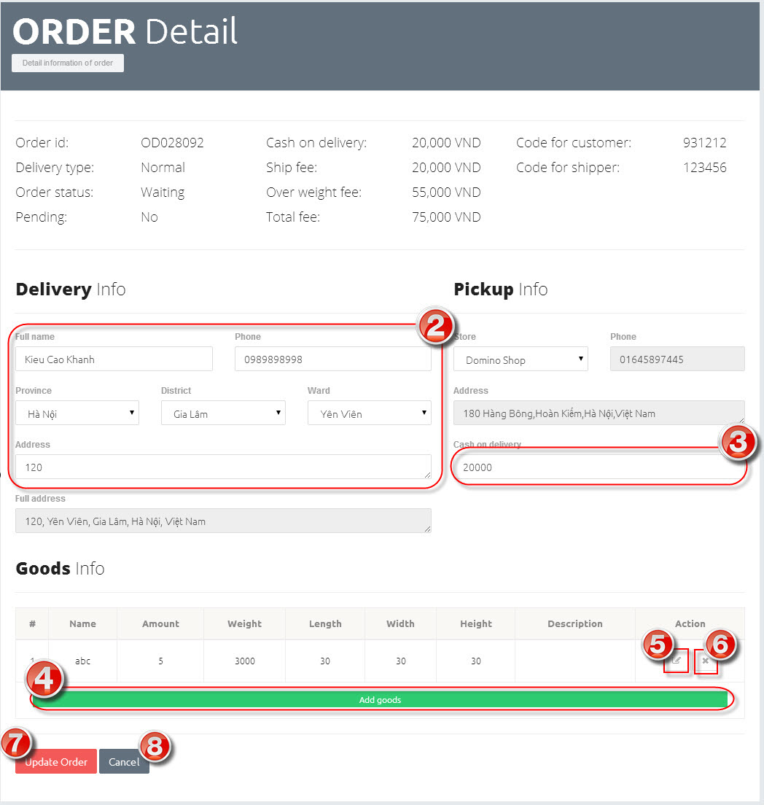

**\* Note:** You can only edit orders that have not been grabbed yet by any shipper or in status “Waiting”

**To view detail of an order:**

**Step 1.** Click on “Edit Order” button (➊). The elements on “Order detail” screen will be enable.

**Step 2.** Edit information of order in text boxes in (➋) and (➌).

**Step 3.** Click on “Add goods” button (➍) to add new goods (see 3.2.5.Add a goods), “Edit” button (➎) to edit a goods (see 3.2.6: Edit a goods) and “X” button (➏) to delete a goods (see 3.2.7. Delete a goods).

**Step 4.** Click on “Update order” button (➐) to update your change or click on “Cancel” button (➑) to discard the change.

##### 2.1.2.12. Search



In each view list screen, there is a search tool to help user to search faster. Store can use this tool to search order or transaction history.

**Screen Description:**

1. Click ➊ to show calendar to pick date
2. Click ➋ to clear date in textbox ➊
3. Click ➌ to choose which type of date will be searched, and some screens don’t have this
4. ➍ Start Date of date range
5. ➎End Date of date range
6. Click ➏ to apply date range after choose start date and end date
7. Click ➐ to Cancel
8. Click ➑ to show filter for search
9. Enter search key into textbox ➒ to search

**To search by date range**

1. Choose date type ➋. If screen doesn’t have drop down list ➋, default type of search date is which type of date in table below
2. Click date range textbox ➊ to pick date
3. Click start date and end date
4. Click “Apply” button ➏, then result will be displayed

**To search by word**

1. Choose type to filter ➑. “All” is search by all information in table below

Enter search key into textbox ➒. Whenever type any key in search textbox, result will be displayed immediately

##### 2.1.2.13. Find a shipper

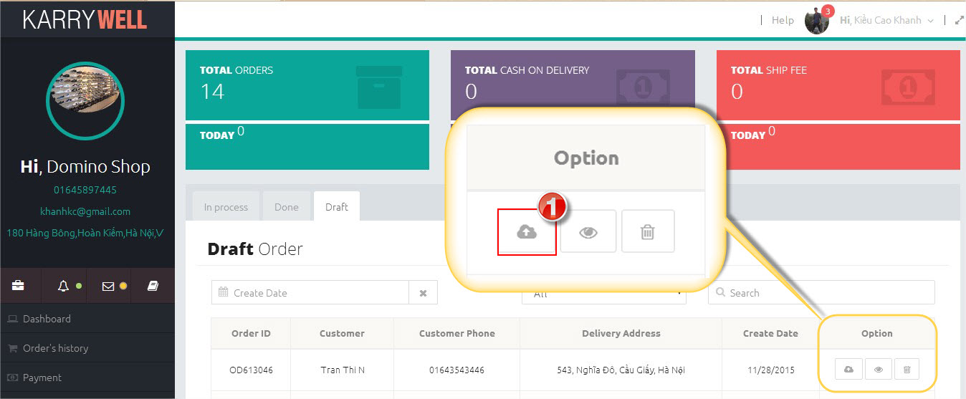

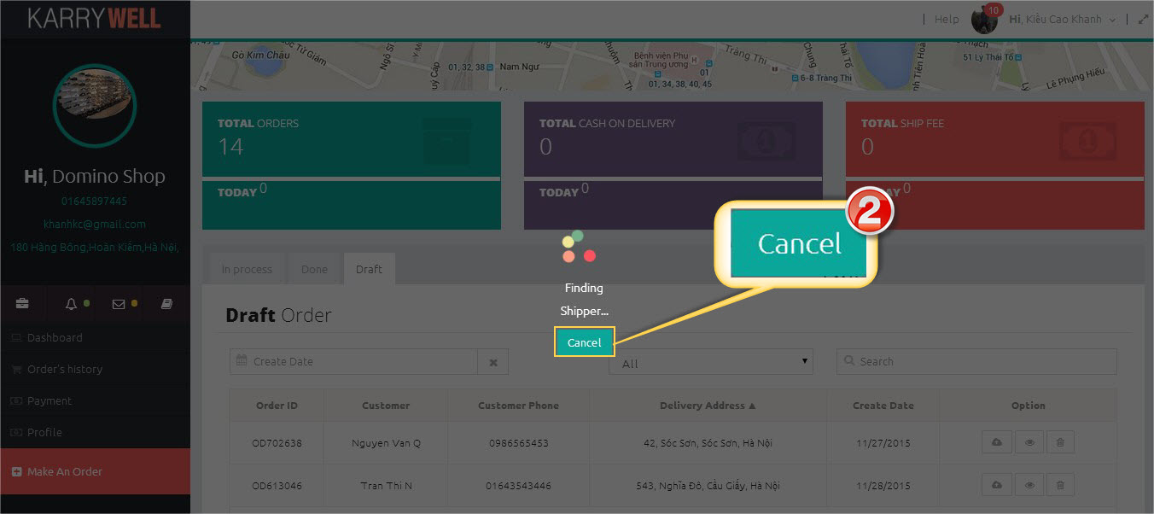

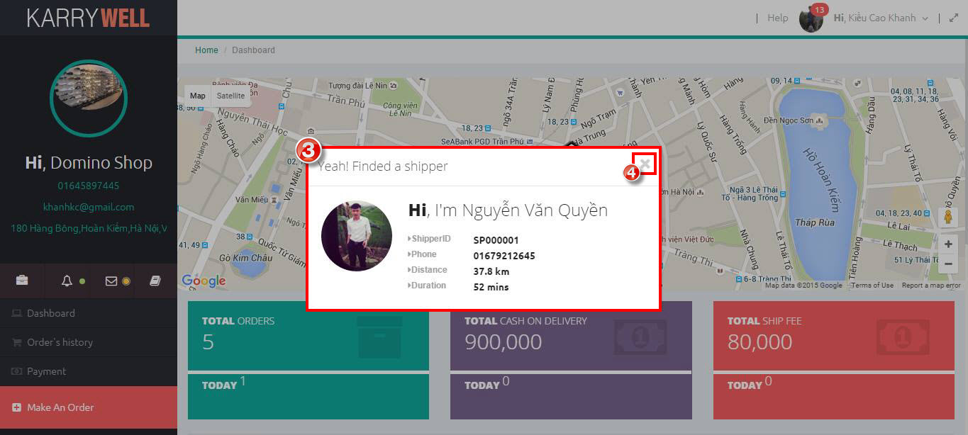

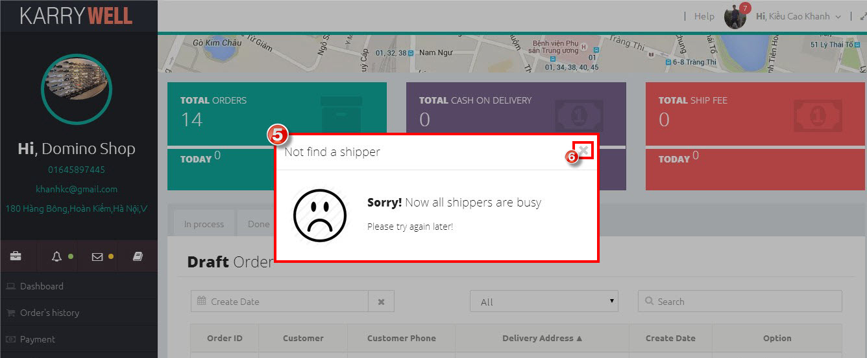

**To find a shipper:**

To find a shipper, **c**lick on “Submit” button (➊). “Find shipper” screen will appear. You can click on “Cancel” button (➋) to cancel finding process.

If finding process is successful a popup will appear (➌). This popup contain information of shipper who’ll come to pick up your goods. Click on “X” button (➍) to close popup.

If finding process is fail a popup will appear (➎). Click on “X” (➏) to close popup.

##### 2.1.2.14. Sign out

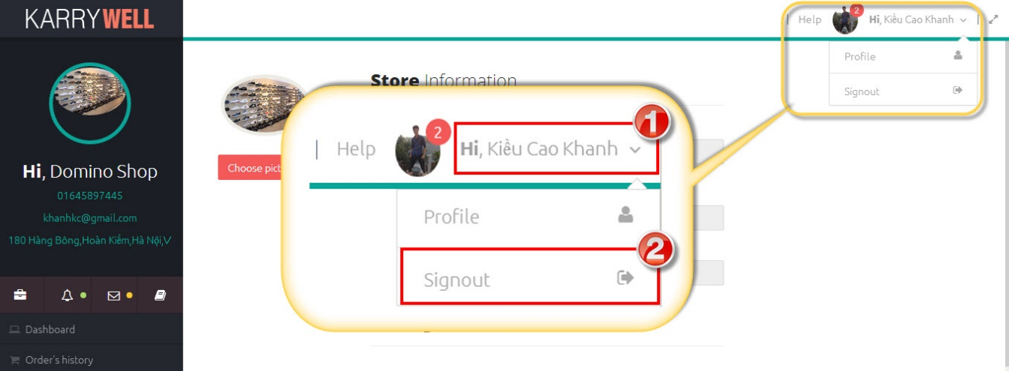

**To sign out:**

**Step 1:** Click on your name on header (➊). A menu will appear.

**Step 2:** Click on “Sign out” item (➋) to sign out.

### **2.2. Mobile Application**

This document guides you how to use Karry Well application. You will need only 10 minutes to learn.

#### 2.2.1. Select Screen

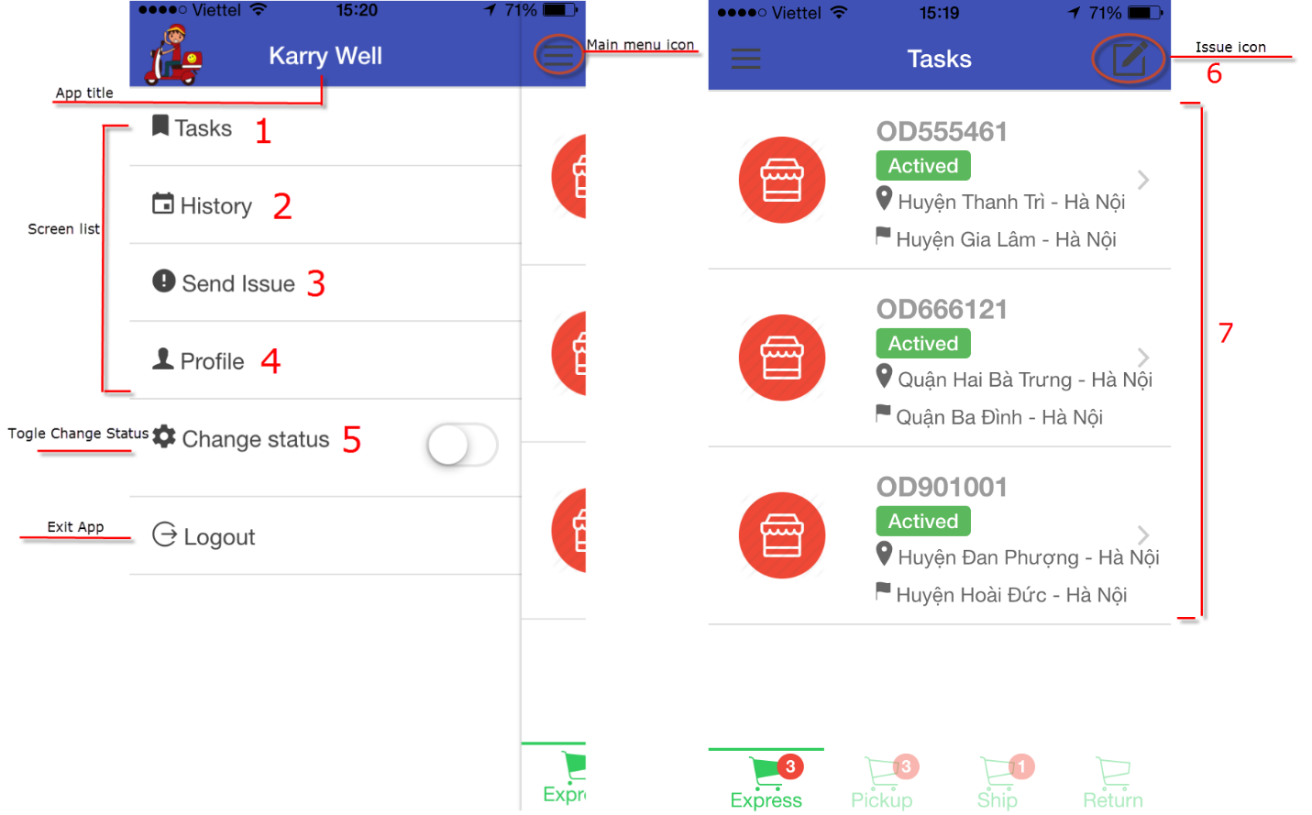

**To select a screen**

1. Tap on Main Menu icon on the upper left corner. The Main Menu will show listing all screen of the application.
2. Tap on the screen that you want to use.

* (1) Tasks Screen: used to view tasks of user.
* (2) History Screen: user want to review history.
* (3) and (6) Send Issue Screen: used to send issue to Admin. When user was issued, then user can send their issue.
* (4) Profile Screen: used to view profile of user.
* (5) Change status Screen: used to change status of user. User want to switch his status between ready to work or not ready.
* (7) Detail Screen: used to view detail of Task. User tap on item, then application redirect to detail screen.

#### 2.2.2. Login Screen

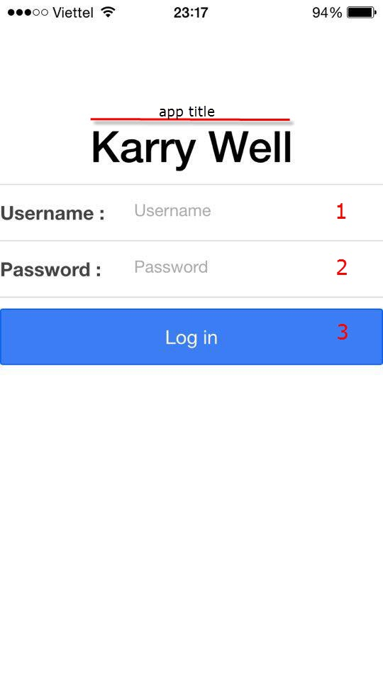

**To Sign-In to Application**

1. Type the text in the text field (1).
2. Type the text in the text field (2).
3. Tap on ‘Login’ button (3).

#### 2.2.3. View Tasks

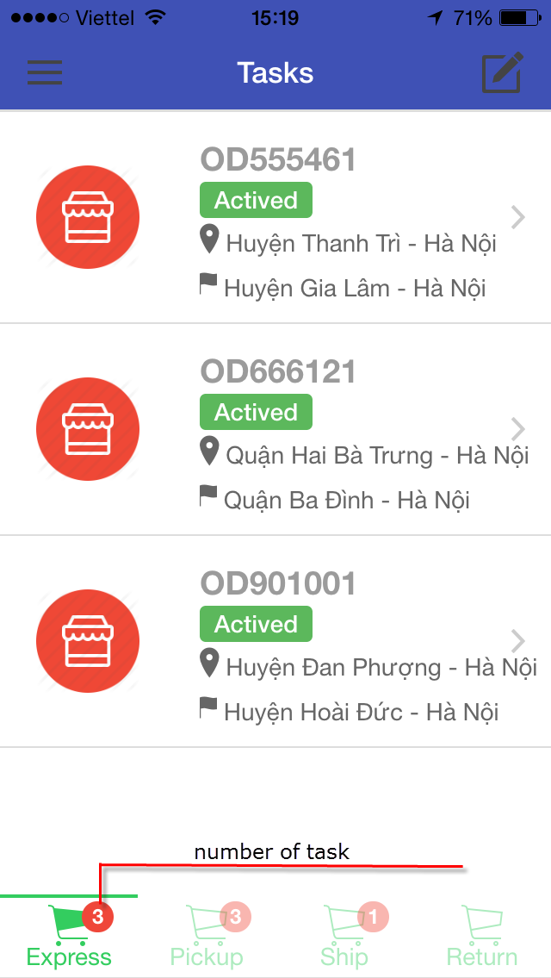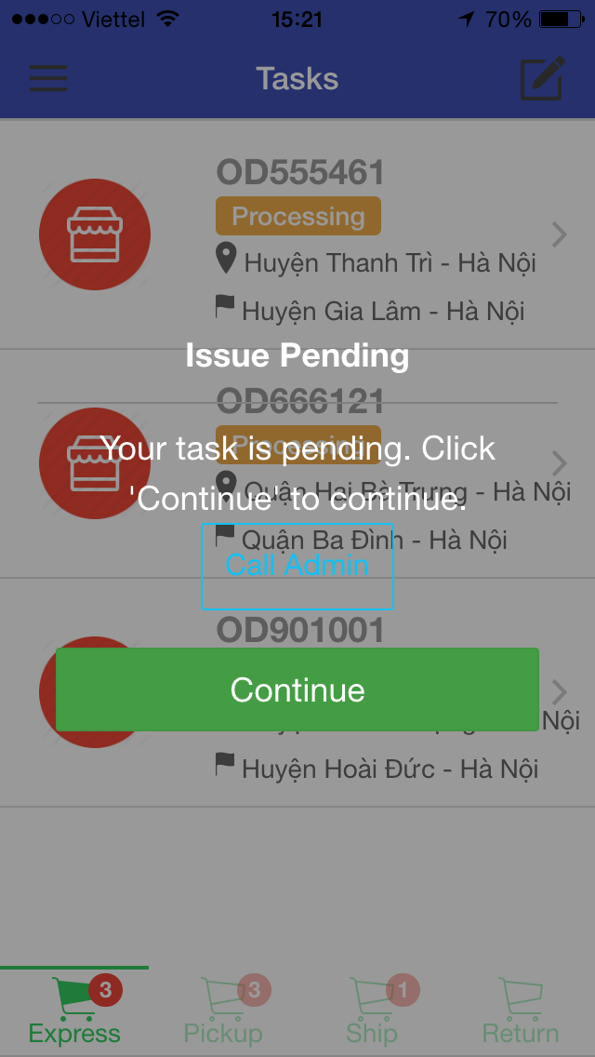

- To view Tasks screen, select Tasks screen from Main Menu (refer 2.1).

- To view detail information of task by tap on each task.

- To view type of task by tap on each tab (Express, Pickup, Ship, Return).

- To view Issue Pending Dialog, send issue from Send Issue Screen (refer 2.4).

**To continue user of task**

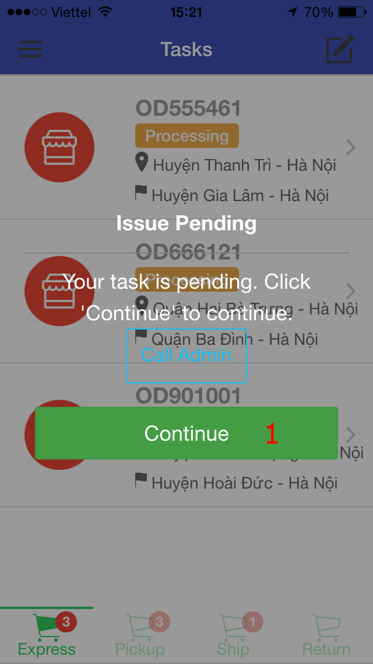

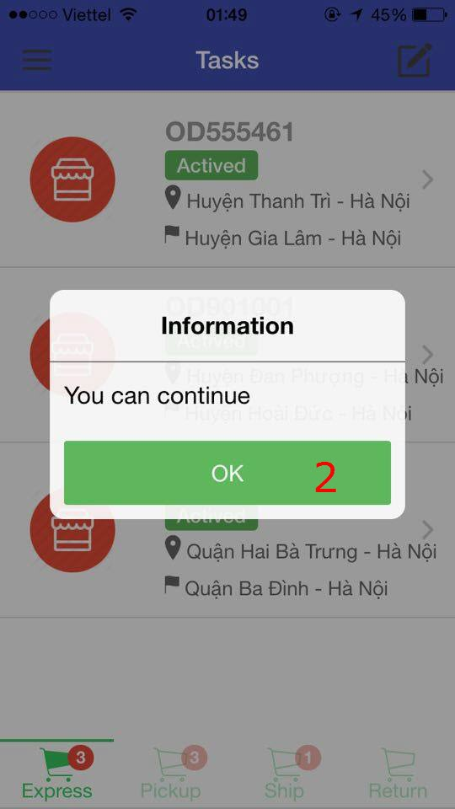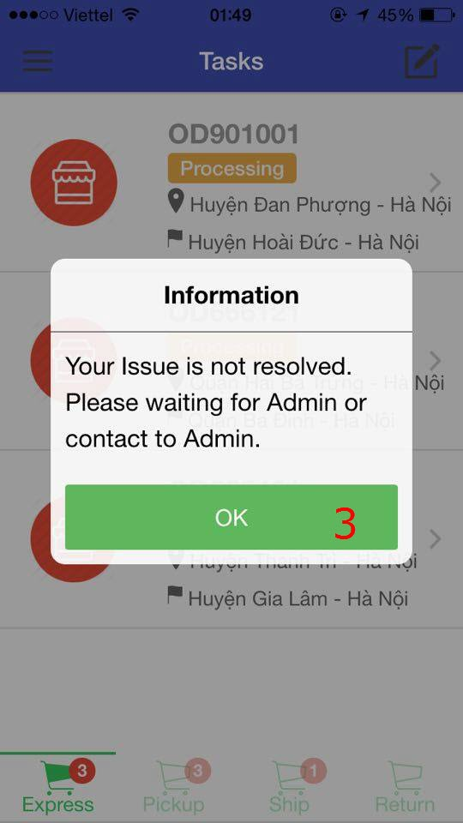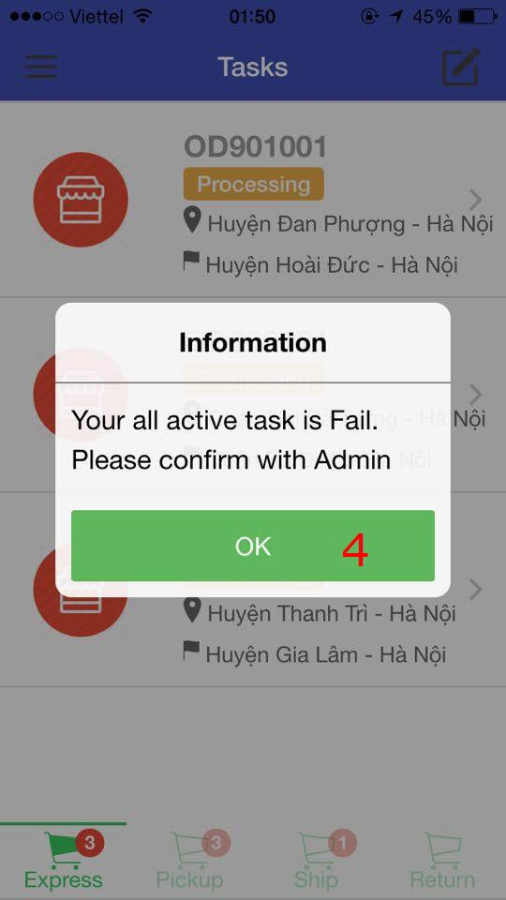

1. Tap on ‘Continue’ button screen (1).
2. If Admin accept for user continue their task, A Dialog (2) appear with content: You can continue.

If Admin haven’t resolve that issue, A Dialog (3) appear with content: Your Issue is not resolved, please waiting for Admin or contact to Admin.

If Admin reject that issue and assign task to other user, A Dialog (4) appear with content: Your all active task is fail. Please confirm with Admin.

1. Tap OK button of the confirmation of dialog.

#### 2.2.4. Send Issue Screen

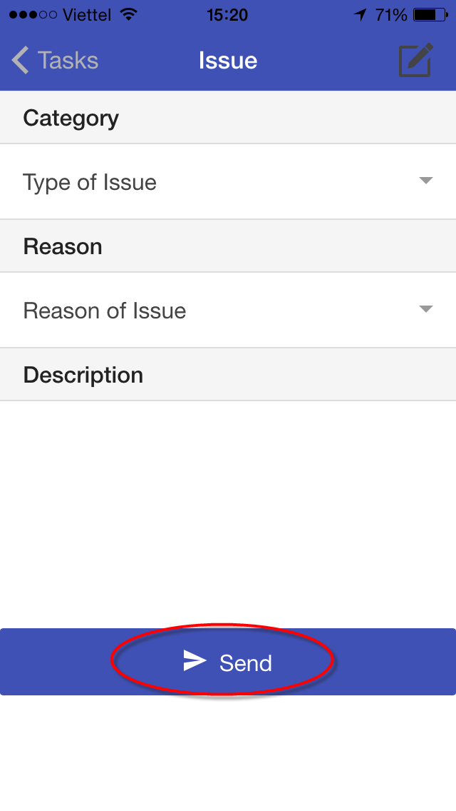

**To Send Issue’s information to Admin**

1. Tap on Category Dropdownlist. (Pending, Cancel).
2. Tap on Reason Dropdownlist (Traffic jam, Vehicle, Accident, Good is Broken, Cannot contact with customer).
3. Type Description.
4. Tap Send button

#### 2.2.5. View Detail’s Task Screen

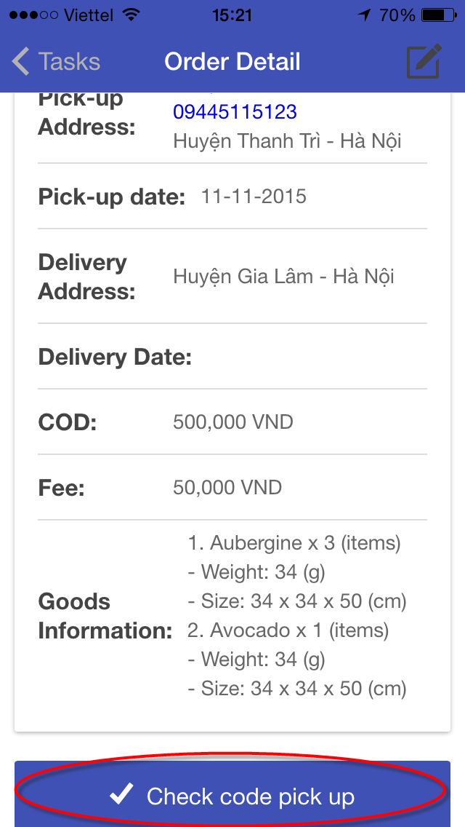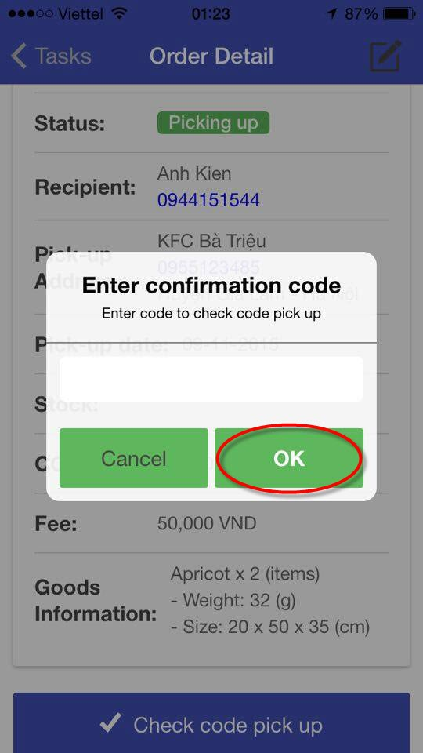

To view Detail’s Task screen, tap on item in list of Task from Tasks screen (see 2.3).

**To check code for Order**

1. Tap Check code pick up button at the end of Detail’s Task screen.
2. Type code on text box of confirmation code.
3. Tap OK button.

#### 2.6. View History Screen

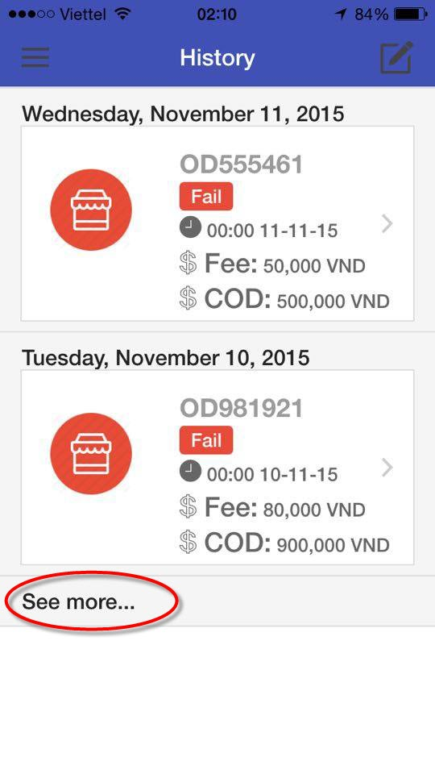

- To view History screen, select History screen from Main Menu (refer 2.1).

- To view detail information of task by tap on each item.

- To view more list of history by tap on See more button.

#### 2.8. Change Working Status

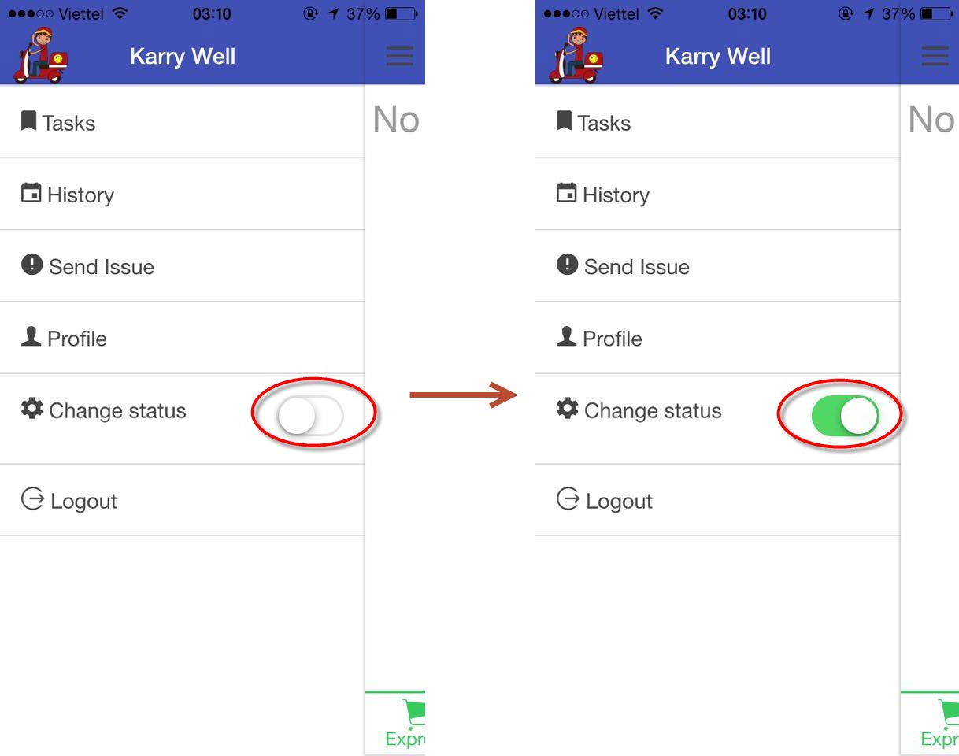

- To change status of current user, tap on toggle Change status.

#### 2.9. Grab Order

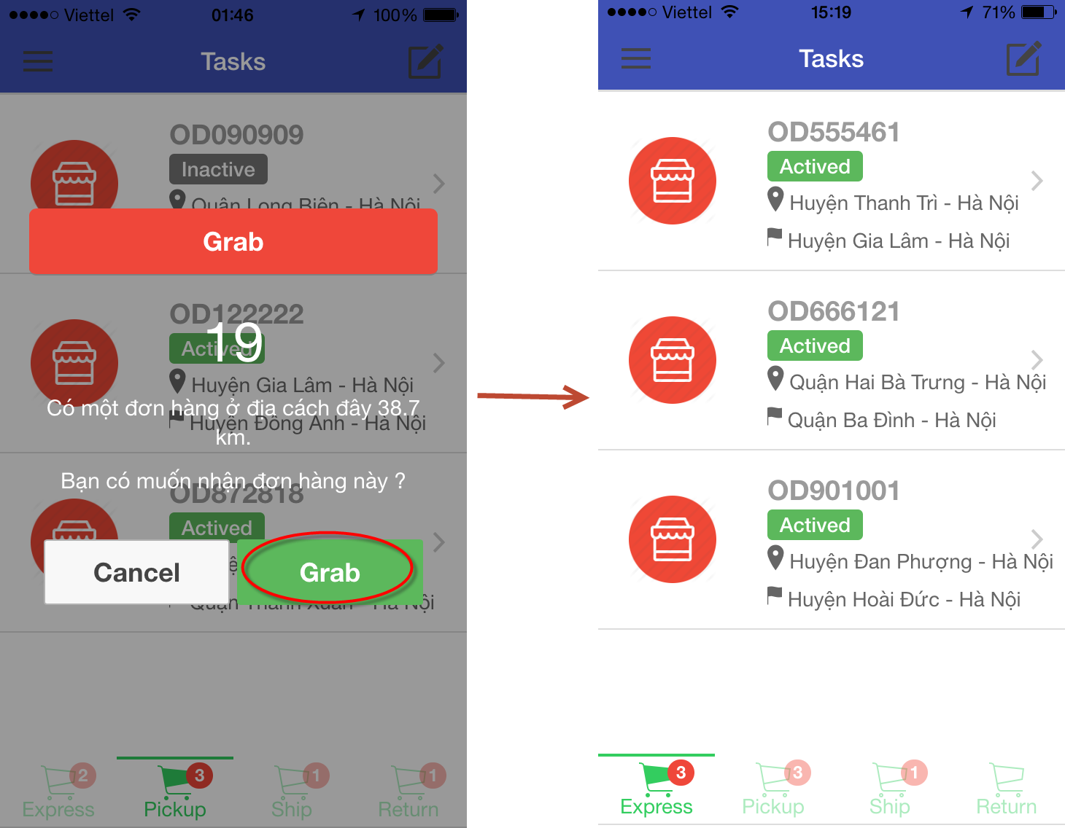

- Tap on Grab button, Task have recently grab, it will appear at tab Express of Task screen.

# APPENDIX